Advanced Internet Technologies Project Report

Group members: Mercy Lio, Alexandru Stan

Abstract — The project as required for the completion of the Advanced Internet Technologies course is to develop a web application using the concepts learned during the lectures. The application is to focus on the presentation of open data to create an execution in which we can view certain data through the use of Databases, and web development languages such as PHP/MySQL, or Java and MS SQL-Server platforms as part of the implementation solution. The aim of the project is such that the data sets as provided by the open data websites (<http://daten.buergernetz.bz.it> , <http://dati.retecivica.bz.it> , <http://data.gov.uk> , etc.) should be visualized using a website as the interface to the users. And this website shall permit sending of messages by the users to a server which will process these requests. This server should establish a connection to a database which in turn contains tables for the data and the users.

Index Terms— Advanced Internet Technologies, HTML, PHP, CSS, JS, Open Data.

INTRODUCTION

The goals as developed from the brief abstract are:

To visualize data sets using a website as the users’ interface.

* This will contain a start page that gives an overview of the sets offered. There should be a possibility to request details of a particular set (simple off-set-shelf visualization should be sufficient).
* A shopping basket feature should be implemented that allows the users to select data for later export in a format like csv.
* A registration feature should be provided and allow the user to enter the name, address, and other contact details. Inputs should be checked for consistency.

The data presentation and registration should be on separate HTML pages. The solution should be responsive, using CSS and JQuery.

There should exist a server that receives messages from the user and processes them. The server has to establish connections to the database.

The database should contain tables holding information concerning the data as well as information concerning the users.

CONCEPTS AND INNOVATION

The web application created for this project is implemented using PHP/MySQL. This application will permit users to request data concerning the people who have had honours bestowed upon them by the queen.

The implementation of this system will use HTML, CSS and JavaScript for the interface of the website in order to make it attractive as well as responsive.

1. HTML

This is a markup language for describing web documents/web pages. It is an abbreviation for Hyper Text Markup Language. It is written using HTML tags which describe different document content. These tags are keywords surrounded by angle brackets: <tagname>content</tagname>.

Tags always come in pairs i.e you always have a start tag/opening tag: <tagname> and an end tag/closing tag: </tagname>. The end tag has a slash at the beginning of the tag name.

HTML is read and rendered by web browsers whose purpose is to use the HTML tags to determine how to display the document.

1. CSS

This is a stylesheet language that describes the presentation of a HTML document. It helps the web page developer to beautify and position elements on the screen.

In a CSS document, a developer would specify the tag (as in the HTML file) that they wish to present as follows: body{background-color:#d0e4fe;}. The html tag here is ‘body’ and the presentation will be whatever is in the curly brackets.

1. JavaScript

This is the programming language of HTML and the Web. Programming makes computers do what you want them to do. Hence, JavaScript is used to program the behaviour of web pages.

1. JQuery

This is a JavaScript Library. It aims to simplify JavaScript programming.

It will also implement a user login and registration capability, brought to life by PHP. This will connect to a database with a table that stores user information. The user will then be able to register and login/logout of the website.

1. PHP

This is a server scripting language. It is used for making dynamic and interactive web pages according to w3schools.com

1. MySQL

SQL is a standard language for accessing databases. There are many database systems such as Access, MySQL, Oracle, SQL Server, among others.

For our project, we decided to use MySQL as it is better known to us as a group.

1. localhost

This is a hostname that means this current working computer. It is used to access the network services that are running on the host through a network interface.

1. REST services

Representational State Transfer (REST) is an architectural style (of the world wide web) that specifies constraints, such as the uniform interface, that if applied to a web service induce desirable properties, such as performance, scalability, simplicity, visibility, portability, reliability and modifiability which enable services to work best on the Web according to the Oracle Java EE 6 Tutorials.

To the extent that a system conforms to the constraints of REST, they can be called RESTful. RESTful systems usually communicate over Hypertext Transfer Protocol (HTTP) that use the verbs GET, POST, PUT, DELETE, etc. that web browsers use to retrieve web pages and to send data to remote servers.

1. Charts.js – this is
2. Shopping Carts - this

From all these concepts, the project meets the requirements set. These are:

* To have a responsive interface.
* To have a nice interface layout.
* To have input checks.
* To have bidirectional data transfer between the user interface (UI) and the database (DB).

The Functional Requirements for this project are:

• To have an overview of data sets.

• Request details of datasets available.

• To have a shopping basket.

• To allow for registration to access the datasets.

• To have a DB with tables for data as well as users.

• It is important for us to show a good DB design! NOT EVERYTHING SHOULD BE SHOWN IN ONE TABLE!!!!!

This project will be created using some of the above mentioned concepts to create a website that will provide data pertaining to the Queen’s Honours List. The website is created as follows:

* The initial page (the index page), provides basic information about what data sets are being provided on the site. It provides some insight into the website and what it’s about, among other things.
* On this page, there is also the ability to login or register in order to actually get the data the site provides.
* Once logged in, the user is able to access the page with the data set information.
* This page calls information that is stored in a database and renders it in form of responsive charts, as well as a brief description of the data provided.
* The user is also able to add the information that they need to a shopping cart which then allows them to ‘buy’ the data set and then later export it into a csv file.

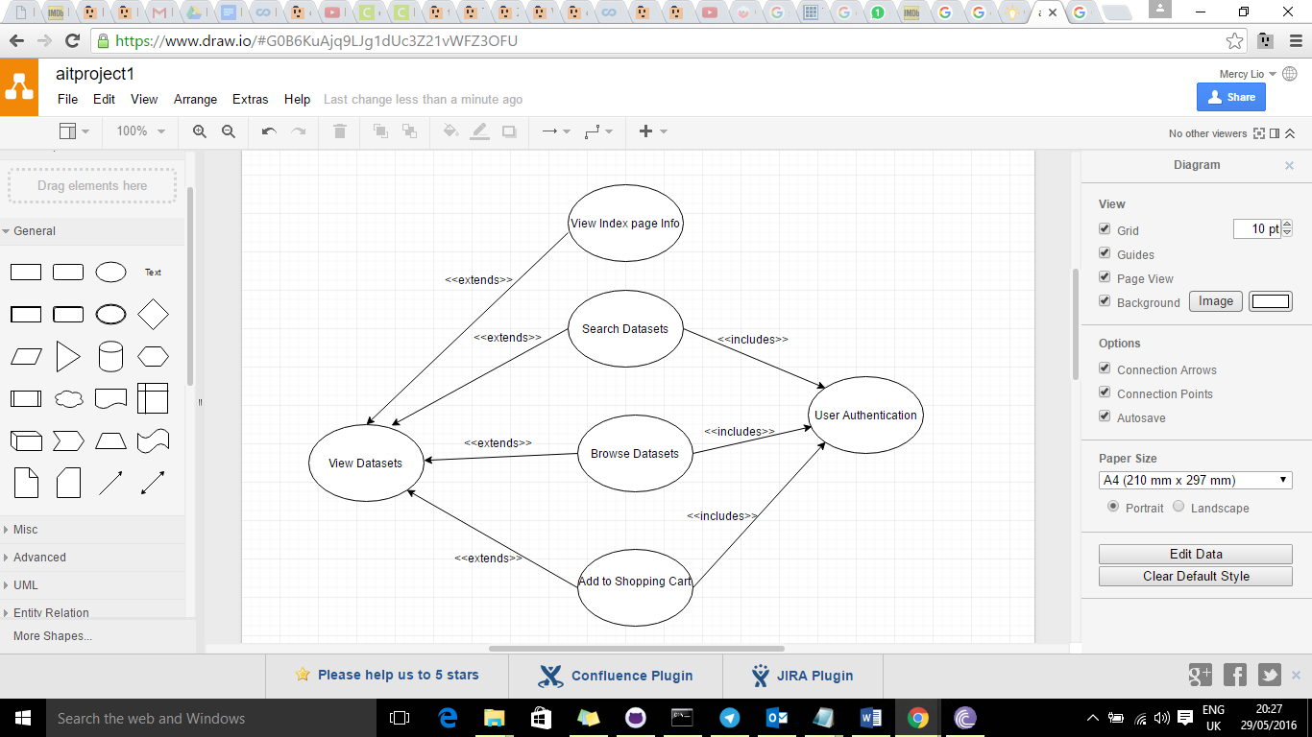

Figure 1: Use Case Diagram of information access on the site.

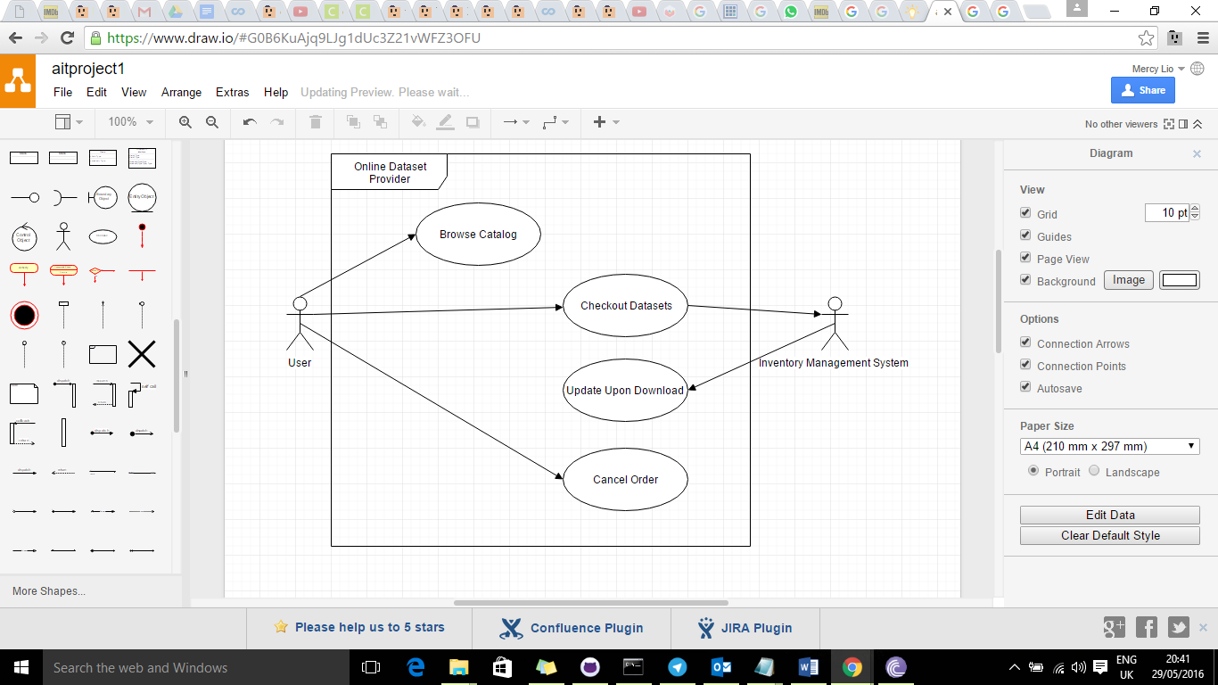

Figure 2: Context Diagram of information access on the site.

This project aims to follow these images to try to achieve all the requirements set for the completion of this task.

Figure 3: Index of the site.

Figure 4: Datasets.

Figure 5: Database.

Figure 6: Login and registration.

Figure 7: Shopping cart.

Figure 8: Information (Dataset) representation using Charts.js .

CONCLUSION AND FUTURE WORK

This project, as far as the course requirements demand, will not be very secure. It is therefore important for us to look into future additions of security measures to this dataset website.

First things first, we are aware that the most valuable asset of this website is the dataset information and its representation. In this case, we need to, first, discover protection measures that will be necessary to protect the database containing this information.

As far as the user is concerned, User information is more important to them than anything. It is therefore convenient for us to protect their information saved on the database, as well as protect in as they enter it for authentication purposes onto the website.

If we just consider the 3 tiers of our system:

* On the Presentation Layer
* On the Logic Layer
* On the Data Layer